January 2007 Number 2

NEWSLETTER

What is the AKPA?

AKPA stands for Aintree Kidney Patients Association and is the brainchild of Dr Bhavna K Pandya, Consultant Nephrologist at University Hospital Aintree. It is to be run by patients (and their carers) and is intended to provide support for kidney patients (and their carers) under the care of Consultant Nephrologists at the University Hospital Aintree.

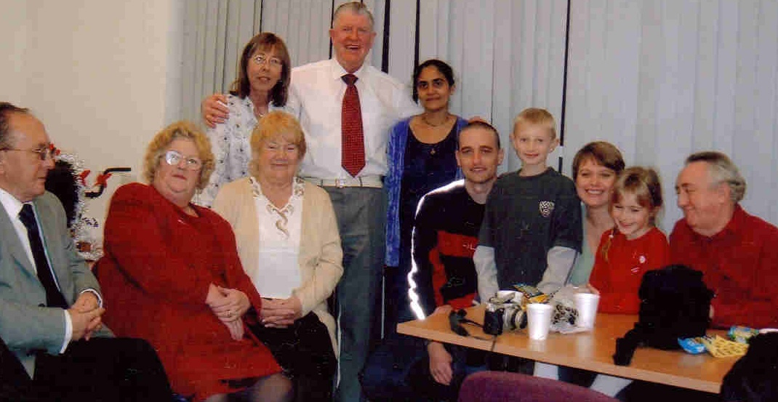

Picture taken at the AKPA Christmas party on Sunday 17 December 2006 showing members of the AKPA committee.(From left to right: Front row: Alex Rowlands (chairman), Trish Fisher (committee member), Beryl Bentley (committee member), Michael Molyneux (secretary), Daniel Molyneux, Lisa Molyneux, Kate Molyneux, Dennis Crane (North West Regional Advocacy Officer for the National Kidney Federation). Back row: June Graham (treasurer), Alan Bentley (committee member) and Dr Bhavna Pandya (Honorary President of AKPA))

AKPA Christmas party

The AKPA Christmas party took place in the Clinical Science building at the University Hospital Aintree on Sunday 17 December 2006. The party was well attended by approximately 75 people with about 30 of those being children who seemed to have a great time being entertained by Mr Alan Bentley and the disco. There was also a tombola which raised about £100 and a raffle which was well supported, also raising about £100.
Our thanks go to all members of the committee for all their hard work in organising the event and for their help on the day.

PTO
Thanks also go to those people and organisations who donated prizes for the raffle and the tombola particularly Proctor and Gamble and Andrew Collinge Hairdressers. Finally thanks to all the patients and families who attended the party and supported the tombola and raffle.
Also thanks go to Lyndsey Burke (Dr Pandya’s secretary). The AKPA is grateful for her genuine support and hard work.

Funds

The AKPA is grateful for all donations received so far. In Late October 2006 Kevin Wainwright celebrated one year since his life saving heart and kidney transplant. As way of a celebration he organised a charity event with funds raised donated to the New Starts Heart Transplant Fund and the AKPA. We are very grateful for this donation and wish Kevin many more years of happiness. We are also grateful to the family of Edward Millward (deceased) who expressed that any donations at his funeral were made to the AKPA.

Future Dates For Diary

Next meetings at Olivia Thomas Suite University Hospital Aintree.

The meetings planned for the next year are due to take place on the third Sunday of each month except for August when there will be no meeting due to the holiday season. We are in the process of asking speakers to come in and talk about hospital/kidney related matters as a way of providing information to patients.
The committee would welcome any suggestions to the type of speakers people would be interested in listening to and would do their utmost to accommodate these.
Future dates for the next 6 Months are, February 18 (Monica from PALS will be speaking at 4pm) , March 18, April 15, May 20 and June17. Possible speakers are, a Dietitian, Transplant Co-ordinator, Social worker and Dr Pandya.

Chairman Alex Rowlands is planning a sponsored wheelchair push from University Hospital Aintree to the Royal Liverpool Hospital (approx 10 miles) on Friday 6 April 2007. Also there is a possibility of an entertainment evening in aid of the AKPA at Longmoor Lane Social Club on Saturday 7 April at 7.30. More info to follow.

Contact No.s:
Alex Rowlands: 01695 725 655
(Chairman) 07717 834 066
Michael Molyneux: 07903 497 281
(Secretary)
Secretary to Dr Pandya: 0151 529 8701

